October 2012
Issue 79
Welcome once again from the stable of M0BPT with this months offering.
I see from comments received that many suffered during the ladder activity, whilst others had good sessions. I look forward with interest to coming months of the ladder.

Lets look at some of the comments received.
<oo0oo>
From Darren. G0OTT
Hi Robert,
Please find my attached log report for October.
I managed 2 sessions this month, both challenging :)
The evening session on the first Sunday, from home was thin on the ground for Fists members, managed several nice QSO's around Europe on 40m, with a change to 80m I found 4 more QSO's with 3 Fists, bingo.
My 2nd session was portable near Totnes south Devon, I managed to get my zepp fed W3EDP up at 60ft and was anticipating a nice day, gremlins took out my bnc connector, then a fuse in power lead. I even brought my amp but did not fancy holding the coax with it running so kept to 3w on my new friend, the KX3
Thank you to the people who pulled me out, apologies for the drop outs when my coax was playing up.
Enjoyed the challenge and was happy to meet up with several members for a better score.

I hope to finish the year with less drama in the closing months.
May I take this opportunity to thank you Robert for all the hard work that you have put into your roll as activity coordinator/brasspounder publisher, you will be missed.
On a plus, we hope to hear more of you on the air.
Regards Darren G0OTT/p
Hello Darren. Thanks for your report and overview. I completely understand how things transpire to thwart a /p operation! No matter how much you plan for things to go wrong, something always happens that you have no control over! I recollect a G7 friend of mine who camped out on top of a hill over a weekend entering one of the many (at the time) VHF actvities; to cut a long story short, he wasn't able to transmit, and nothing available to repair the problem, he decided to stick to his guns and entered the receiving station section, where he came in the top five I believe! If that would have been me, I'm afraid I'd have muttered many expletives under my breath, packed up and gone home! HiHi. So my respect to you for carrying on regardless.
<oo0oo>

From Graham. G3ZOD
Hi Rob. The 14th October found me with a bout of "man flu" and feeling a couple of dits short of a dah. However, determined not to give in to it, I plodded into the shack at 14:00 and onto the first port of call, 20m. No sign of Erkki OH7QR, who is usually to be found at that time, so I tried CQing for a while and was rewarded by a call from Ike DL2IKE/P. Generally folk out /P on 20m don't hang around, so I was pleasantly surprised to have a long chat with Ike, who had cycled to a lakeside QTH along with his wife, young daughter and large battery, and was on the air with a Wilderness ST and a PAC-12 aerial. Afterwards (14:45) I tried some more CQs but no replies, so I dropped down onto 40m, which was very quiet - no signs of FISTS members. Nothing further happened until 15:00 when Phil 2E0DPH called, then I happily had QSOs until 15:58. I was surprised when Peter G4LHI called me at 16:02 after the Ladder had finished and then heard other FISTS QSOs in progress... at this point the penny dropped that due to my addled brain, I had come on originally an hour too early (14:00 local time instead of 14:00 UTC). Argh! Still, I would otherwise have missed the very nice QSO with Ike. By the evening, I decided it was too much and stayed away - perhaps operating radios, like driving cars, should be frowned up when the operator is under the weather! HI.

I did manage both sessions on the 28th October, with a very successful afternoon. One surprise for me was that while waiting for Erkki OH7QR and Peter G4LHI to finish their 20m QSO, I could actually hear Peter. This is a distance of 100 miles and is very unusual for me on 20m with my very "deaf" indoor aerial. The evening session proved a bit mediocre with 40m skip longer than desirable for the Ladder.

Outside the Ladder, I was pleased to meet up with Erkki OH7QR on 12m, which is a new band for us. I've been about on 10m and 12m from time-to-time recently, with a few QSOs in the USA including over to the West Coast, which again is very rare for me.

Attached is a photo that John M0CDL sent me of his Halloween pumpkins! I can't think of much of an excuse to include it other than Halloween has just gone by and they are magnificent and deserve to be seen!

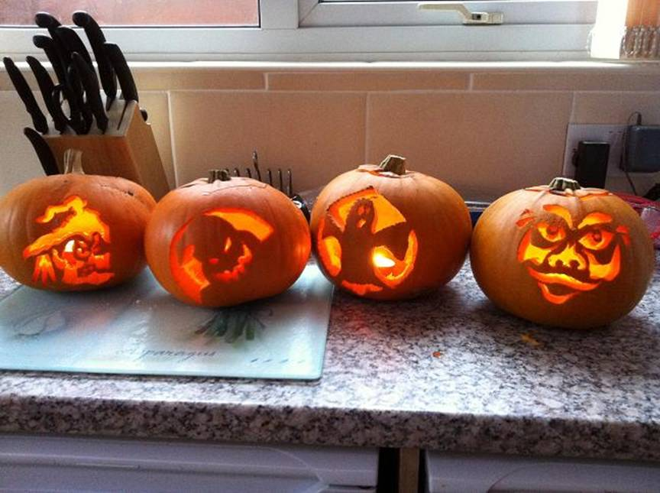
Hi Gra. Hmm.. How many times have we (me included) made a mistake when the clocks change. You're not on your own my friend :) The man flu has a lot to anwer to, on the plus side, it's a marvellous excuse for mistakes made! HiHi.
M0CDL's pumpkins? Magnificent indeed! From the left, the second and fourth ones..I wonder who he was thinking of when he carved the faces??? HiHi.
<oo0oo>

From Erkki OH7QR
Hello Robert,
Hope you are well. I send attached my log for October Ladder. Thanks to Gra (MX5IPX) and Mark (GX2HDF) for club station points not forgetting Peter G4LHI and other members. Hope to work you all in November.

73 de Erkki OH7QR

Hello Erkki. Good to hear from you. It was a suprise to see GX2HDF in members logs this month; operated by my good friend Mark M0BLT.
<oo0oo>

From Phil, 2E0DPH
Hello Rob,
Hope you are well, here is my latest log for the October Ladder Activity.
Once again good conditions on the air on both Sunday afternoons with plenty of activity from both Fists members and non members to keep me busy throughout the session. Many thanks to all again to all.
73 Phil 2E0DPH Fists 14543

Hello Phil. Glad you had a productive October ladder. Always a pleasure to hear from you.
<oo0oo>

From Peter G0TLU
Hello Rob,
Only managed one session this month due to a romantic weekend in Paris clashing with the first Sunday. I did (very) briefly think of taking the '817 along, but soon realized The Management would not be impressed!
Nice to meet for the first time Wanda G4GBX #514 running QRP in Devizes.
73, Pete G0TLU #10803

Hello Pete. Good to hear from you.. OOPS! The '817, romantic weekend in Paris do not go together! HiHi. I'm glad that you erred on the side of caution! We all must agree that the "Management" put up with a lot from us.. however, hope you both enjoyed the weekend away, and on the plus side Pete, you've got an excuse to return with the radio next time!

<oo0oo>

From Derek M0DRK
Hi Robert, Pleased find attached my log for the Oct. Ladder. Thanks once again to all stations that I worked. MX5IPX and GX2HDF certainly gave my score a big lift, thanks to Gra and Mark. Very pleased to meet for the first time, Alan, G4GLV, nr.1131. Hope to meet you again soon Alan.
I'm sorry to note that at the end of 2012 you will be standing down from your duties as Fist Activities Manager, UK. You really have done a great job since you took over the position and you will be a hard act to follow. I'm glad that you will continue with your other Fists duties. You deserve a break Robert and maybe get time to perhaps take part in Fists Activities yourself if you so wish. Take care mate, see you next month, Derek M0DRK, 8344.

Hello Derek, as ever always a pleasure to hear from you. Yes. as said earlier; very pleased to see GX2HDF on air once again, also Gra with MX5IPX. The three and five point call-signs certainly do boost entrants scores. Hope yourself and Mollie are keeping well.

<oo0oo>
And from Peter G4LHI

Hello Rob,

I attach my claim & report for Activity Ladder October 2012.
Well Rob, it is a pleasure once again to say conditions were “good” for us for the October Ladder I thoroughly enjoyed the event as usual, the good conditions made it so much more enjoyable, & I do hope this is a sign that we may be blessed with good conditions for at least to the end of the year.
Both the Sundays I had the same number of QSO’s, but was fortunate to work Mark with GX2HDF for 3 points on the first Sunday & Graham with a nice 5 pointer on the second Sunday, many thanks to both for joining in the fun.
I was also very pleased to work David G4DXX & Jim GW0BBO for the first time & welcome you both to the Fists Club,& hope you will be regular members on the Ladder & other Fists Activities.
For October I had 22 QSO’s for 47 points, not quite as good as last month, but very pleased with the smashing QSO’s
Thank all of you that joined in & supported this event & look forward to working those that I worked for the first time, many more times.
Thank you as always Rob for the very interesting Activities you provide for us & looking forward to the next Activity, the SK Week in December
Keep bashing the brass & good hunting to you all, & most of all have fun whatever the conditions!

73 de Peter G4LHI # 2219

Hello Peter. As ever, many thanks for your report and overview for the month of October. I've noticed of late that many new members to the society find their way into members logs during the ladder activity; this illustrates my comment on many occasions that all activities that the society puts on are an agreeable place to meet and chat with the memembership.

<oo0oo>

Some awards news; Thanks to Dennis K6DF, FISTS Awards Manager, for the following information.

October 2012 FISTS Awards
Congratulations to the following member:
Bob W9UCR #12934 Basic Century
<oo0oo>

Thats all from me for another month, a G4LHI reminds us all, the next major activity is the Straight Key Week (SKW) in December.

I've received a couple of "Mugshots" from our friends in FDU. They will be added to the mugshots page on this site; but I've published them here for you to put a "Face behind the key" Whilst I have your attention! thanks to VK2CTN and VK3FGE for the images and supporting the project.
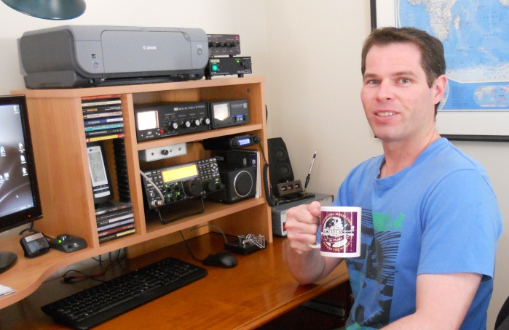 | 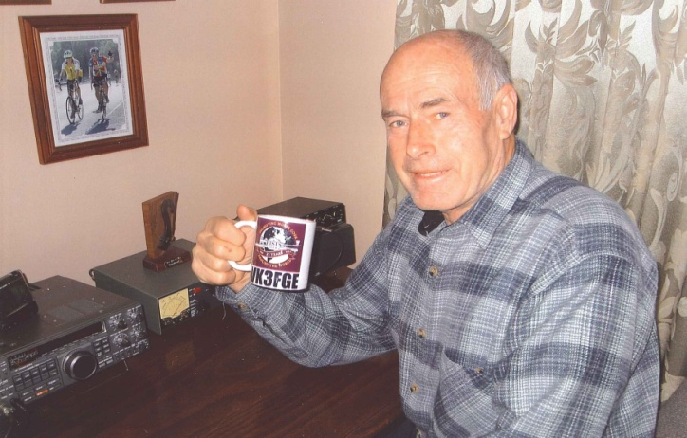
VK2CTN | VK3FGE

On to the ladder table for the month.
CALL | JAN | FEB | MAR | APR | MAY | JUNE | JULY | AUG | SEPT | OCT | NOV | DEC | TOTALS
G4LHI | 36 | 36 | 44 | 46 | 40 | 33 | 25 | 40 | 53 | 47 |  |  | 400
2E0DPH | 29 | 30 | 44 | 27 | 32 | 31 | 29 | 32 | 40 | 35 |  |  | 329
G0OTT | 24 | 31 | 32 | 37 | 27 | 31 | 30 | 0 | 28 | 28 |  |  | 268
OH7QR/OG9R | 31 | 25 | 30 | 23 | 6 | 27 | 24 | 30 | 26 | 24 |  |  | 246
M0DRK | 23 | 20 | 29 | 26 | 15 | 16 | 17 | 23 | 19 | 25 |  |  | 213
G3ZOD | 8 | 19 | 10 | 18 | 6 | 16 | 6 | 17 | 14 | 21 |  |  | 135
G0DDX | 20 | 25 | 29 | 0 | 7 | 16 | 10 | 4 | 10 | 0 |  |  | 121
G0TLU | 0 | 0 | 15 | 10 | 9 | 14 | 7 | 6 | 21 | 8 |  |  | 90
M5ABN | 27 | 31 | 11 | 0 | 0 | 0 | 0 | 0 | 0 | 0 |  |  | 69
2E0JCY | 0 | 0 | 18 | 14 | 0 | 0 | 0 | 0 | 0 | 0 |  |  | 32
G0DUB | 12 | 6 | 11 | 0 | 0 | 0 | 0 | 0 | 0 | 0 |  |  | 29
G0ANV | 8 | 0 | 0 | 20 | 0 | 0 | 0 | 0 | 0 | 0 |  |  | 28
DL4FDM | 0 | 17 | 8 | 0 | 0 | 0 | 0 | 0 | 0 | 0 |  |  | 25
CN2JV | 4 | 0 | 6 | 0 | 0 | 0 | 0 | 0 | 0 | 0 |  |  | 10
PA1FOX | 0 | 0 | 0 | 0 | 0 | 0 | 0 | 8 | 0 | 0 |  |  | 8
SQ5RIX | 0 | 7 | 0 | 0 | 0 | 0 | 0 | 0 | 0 | 0 |  |  | 7
SA0AAZ | 0 | 0 | 0 | 6 | 0 | 0 | 0 | 0 | 0 | 0 |  |  | 6
MM6SRL | 0 | 0 | 0 | 0 | 0 | 0 | 6 | 0 | 0 | 0 |  |  | 6
SM6DER | 0 | 0 | 0 | 0 | 0 | 0 | 2 | 0 | 0 | 0 |  |  | 2
MX5IPX © | 3 | 11 | 3 | 12 | 13 | 14 | 10 | 16 | 18 | 12 |  |  | 112
GX3ZQS © | 0 | 12 | 0 | 10 | 0 | 0 | 0 | 0 | 0 |  |  |  | 22
GX0IPX © | 0 | 0 | 19 | 0 | 0 | 0 | 0 | 0 | 0 |  |  |  | 19

<oo0oo>

Finally, I would like to say "MANY THANKS" to all who've emailed me and commented through this medium regarding my decision to step down from the activity co-ordinator. I've been touched by your messages of support and thanks for my efforts over the past years, and it is appreciated!

The society has of yet received no offers of interest from anyone willing to take on the position, I do hope that a member will come forward and take on the mantle.. please register your interest if you're able to.. I look forward to hearing from any like-minded individual; and I'm only happy to help with advice etc.
Until next time.
Keep well,
Keep pounding brass
73
M0BPT

